WEST YORKSHIRE FIRE & RESCUE SERVICE

JOB DESCRIPTION

POST TITLE: | Fire Protection Administrator – Training, Support & Performance
GRADE: | Grade 2
RESPONSIBLE TO: | Fire Protection Supervisors – Support & Performance
PURPOSE OF POST: | To assist with the management and administration of training, support and performance within the Fire Protection Department
ORGANISATIONAL CHART

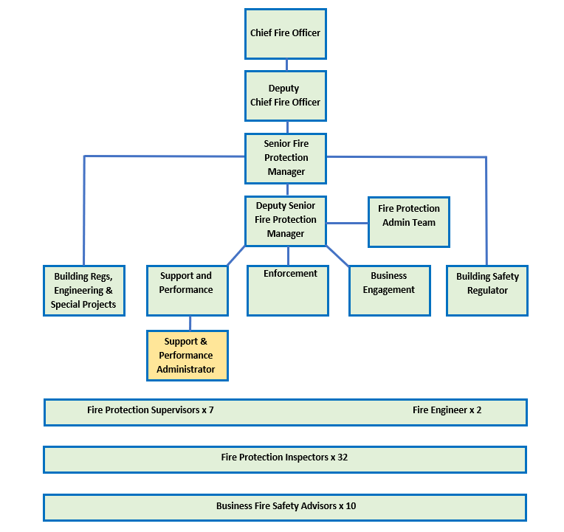

MAIN DUTIES AND RESPONSIBILITIES OF THE ROLE

- Provide comprehensive administrative support for the Fire Protection Training Support and Performance team, including dealing with routine emails, post, calls and reviewing documents and forms as necessary.
- To support with the management and monitoring of the Fire Protection Training Programme and CPD training.
- To be responsible for planning and booking resources; including diarising appointments, ICT access/arrangements, arranging trainee review meetings and team meetings.
- Prepare agendas and take minutes for team and departmental meetings, maintain meeting records and monitor action plans as necessary.
- Manage the booking of external training courses for the Fire Protection Department, including responsibility for co-ordinating arrangements with team managers, Inspectors and external parties.
- Manage trainee paperwork, including ensuring work is submitted on time and is accurately recorded.
- Co-ordinate trainee shadowing and mentoring timetables through liaison with team managers, Inspectors and trainees.
- Distribute publications and ensure the Support and Performance records are up to-date.
- Monitor the training budget spreadsheet and training records spreadsheet. Raise any budget queries with respective managers and training record issues with the training administration team.
- To be the designated Co-ordinator with external training providers regarding training and course queries and delegate support requirements, through liaison with team managers, inspectors, and trainees.
- Liaise with other departments and attendees regarding Operational Fire Protection Training/Refresher Training arrangements and administration where required.
- Printing and preparing all internal course materials and booking resources.
- Responsible for updating and monitoring training team records and liaison with Training Admin team to ensure qualifications are accurately maintained within Access system.
- Where necessary, assist with the management and monitoring of the Fire Protection Database, resolving minor related database queries and update with acknowledgements, special considerations, and primary authority schemes.
- Provide basic training in the use of the Fire Protection Database and assist users with entering data where necessary.
- To support with the testing of development work and changes to the Fire Protection database.
- Responsible for producing standard management reports and gathering information for performance management, quality checks/assurance and annual statistical returns; including data cleaning as required.
- Assist with Freedom of Information and data gathering requests.
- Assist with updating and uploading the National Enforcement Register.
- Receive and appropriately deal with requests from members of the public, external agencies, and internal departments, including accurately entering data on the Fire Protection Database.

ORGANISATIONAL WIDE RESPONSBILITIES:

- Adherence to the Core Code which sets out five ethical principles, based on the Seven Principles of Public Life.
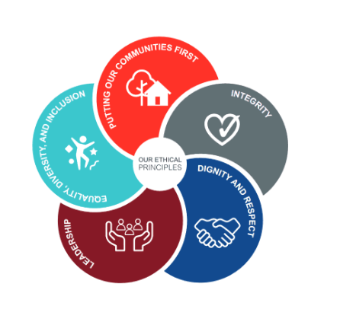

- To Implement and promote the Authority’s:
- Health and Safety policies.
- Equality and Diversity policies.
- Information Security Management System policies.
- Safeguarding policies.
- Business continuity policy and contingency arrangements.
- Policies related to General Data Protection Regulation and Data Protection Act 2018.
- Commitment to maintaining our Customer Service expectations.

SKILLS AND EXPERIENCE REQUIREMENTS FOR THIS ROLE.

In the supporting statement section of the application form give clear, concise examples of how you meet all of the Essential person specification criteria (i.e. items you must be able to do from day one to be able to do the job), identified as ‘Application’ in order to be shortlisted for this vacancy. If a large number of applications are received, only those who also meet the Desirable criteria, identified as ‘Application,’ will be shortlisted, i.e., criteria you need to do the job, but which could be learnt during training.

Please list or number the competency criteria below against which you are providing evidence/examples in order to structure your supporting statement in a well organised way.

There may be some criteria that are identified through ‘Selection Process’ only. You will only be assessed on these criteria during the selection process and not from your application form, this may involve tests, presentations, interview etc.

 | Experience. | Essential/ Desirable. | Where identified.
 | Experience of using Microsoft Word, Excel and PowerPoint. | Essential | Application
 | Experience of using databases, including the ability to interrogate databases and produce reports. | Essential | Application
 | Administrative experience including knowledge of financial and administration systems. | Essential | Application
 | Experience of data capture to produce accurate statistical information. | Essential | Interview
 | Good understanding of the database used by Fire Protection. | Desirable | Application

 | Education and Training. | Essential/ Desirable | Where identified.
 | Must demonstrate a good standard of education and be both numerate and literate.  - Literacy and Numeracy at Level 2 / GCSE Maths and English Grade C or above OR  - Equivalent qualifications OR  - Equivalent level of literacy and numeracy gained through work experience. | Essential | Application
 | Qualified to NVQ level 3 in business administration or equivalent | Desirable | Application

 | Special Knowledge and Skills. | Essential/ Desirable. | Where identified.
 | Ability to work as part of a team. | Essential | Application
 | Ability to work flexibly in relation to the needs of the post. | Essential | Application
 | Ability to work on own initiative, to work under pressure and to meet deadlines with little supervision. | Essential | Application
 | Good organisational and problem-solving skills. | Essential | Application
 | Experience in organising resources and establishing priorities. | Essential | Interview
 | Possession of excellent communication, verbal and written skills. | Essential | Application & Interview
 | Be able to effectively collate, analyse and present information. | Essential | Interview
 | Demonstrate commitment to good data quality within all areas of work. | Essential | Interview
 | Demonstrate an understanding of the importance of equality and diversity to WYFRS as an employer and service provider. | Essential | Application
 | To hold and maintain a current full UK valid car driving licence. | Desirable | Application

Job Description: Last updated: August 2024

